**Drawbacks in Analytica:**

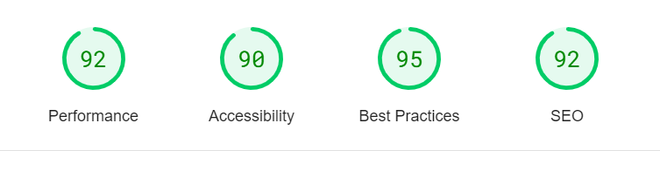

I would say that Our website has better than average performance of the other websites. The image shows that our website has a score of 92 for performance, 90 for accessibility, 95 for best practices, and 92 for SEO. These are all very good scores, and they indicate that our website is well-optimized for speed, usability, and search engines.

But we need to Optimize website up to 100% so, we need to well-optimized the (performance, accessibility, best practices, and SEO)

**Drawbacks in Performance:**

**1: Convert images from PNG or JEPG format to Webp and AVIF format**



Image formats like WebP and AVIF often provide better compression than PNG or JPEG, which *means faster downloads and less data consumption*.

These images are given below

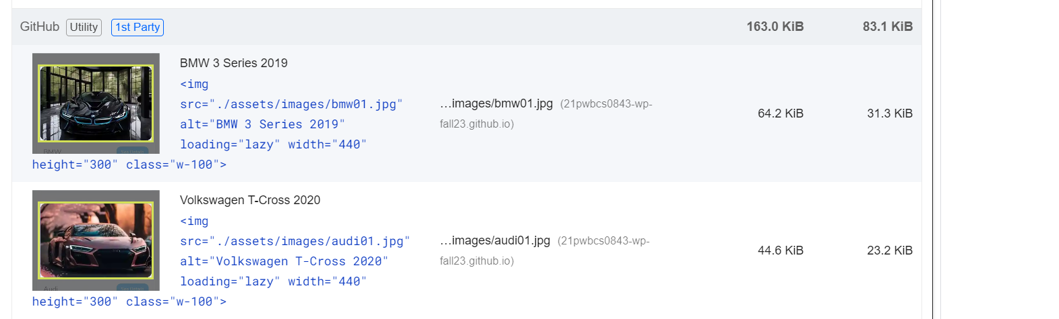

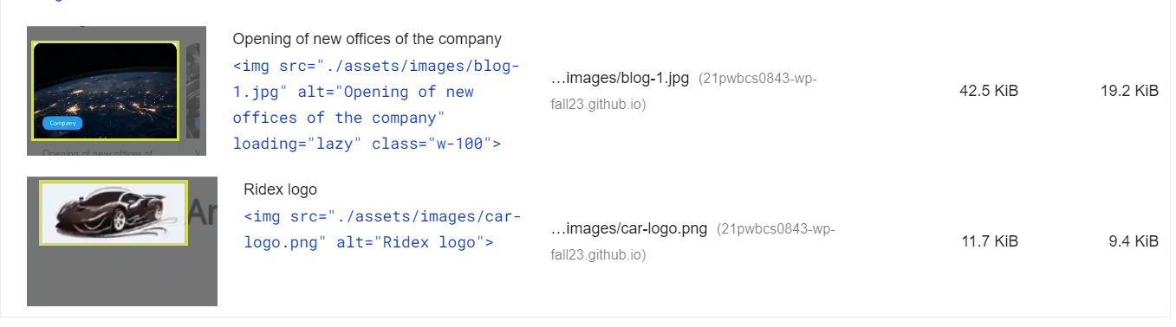

**2:Eliminate render-blocking resources**



Eliminate render-blocking resources means that resources are blocking the first paint of your page. Consider delivering critical JS/CSS inline and deferring all non-critical JS/styles.it is consume much time

The page we need to visit and make changes link are given below

[/css2?family=Nunito:wght@400;600&family=Open+Sans&display=swap](https://fonts.googleapis.com/css2?family=Nunito:wght@400;600&family=Open+Sans&display=swap)

**To avoid this problem follow the link below**

https://youtu.be/mqBtE7uNxN4

**3: Image elements do not have explicit width and height**

Set an explicit width and height on image elements to reduce layout shifts and improve CLS(Cumulative Layout Shift)

The images are

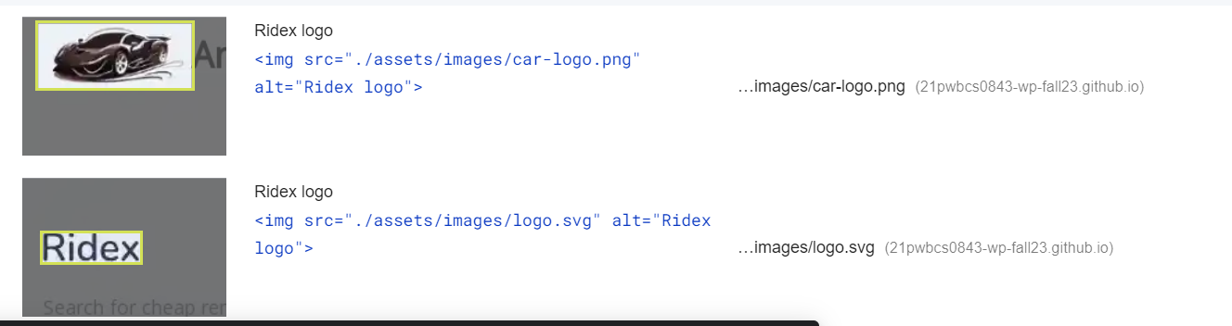

**To avoid this problem**

img {  
  width: 100%; /* or max-width: 100%; */  
  height: auto;  
}

**4:** **Largest Contentful Paint element**

LCP(Largest Contentful Paint) measures how quickly the largest element (image or text) loads. Here the test are so large.

The images are

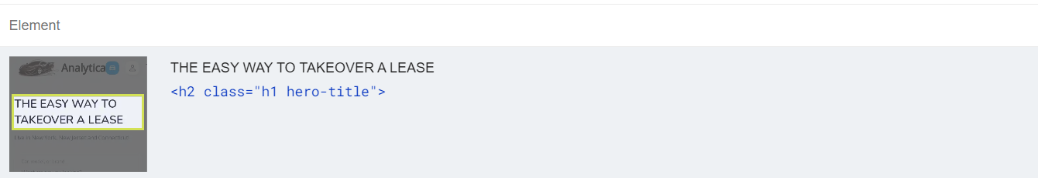

**To avoid this problem**

Small the text size

**Drawbacks in Accessibility:**

**1: Buttons do not have an accessible name**

Buttons without accessible names are problematic for users relying on assistive technologies like screen readers. These tools announce "button" instead of the button's actual function, leaving users confused and unable to interact effectively.

**To avoid this problem**

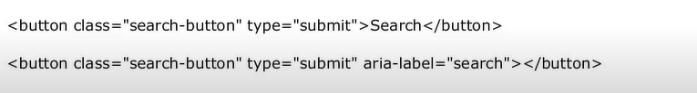

**OR**

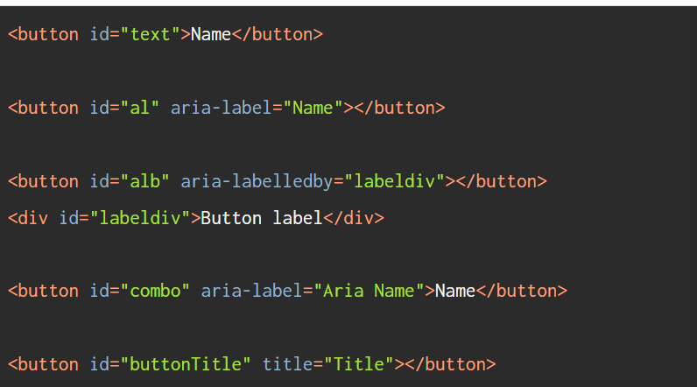

**Drawbacks in SEO:**

**1:** **Document does not have a meta description**

A meta description is an HTML attribute that summarizes a web page's content. It's displayed in search results, appearing underneath the title of your page. While it doesn't directly impact your SEO ranking, it plays a crucial role in influencing users to click on your page.

**To avoid this problem**

**Example:**

<meta  
  name="description"  
  content="Mary's simple recipe for maple bacon donuts  
           makes a sticky, sweet treat with just a hint  
           of salt that you'll keep coming back for.">